Assignment 3

Sai Deepika Gopala

1. State Diagram:

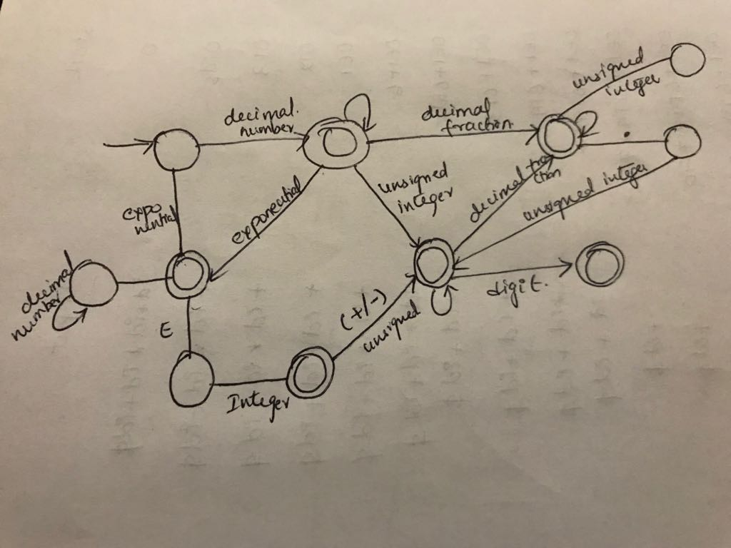

2.

S🡪a|Ab|B

A🡪BA’

A’🡪aaA’|SbA’|ε

B🡪b

3.

After removing the left recursion, we get:

A 🡪BA’

A’🡪 dA’| ε

B 🡪 ab

Now, we can see that

First(A) = {a,b,d}

First(B) = {a,b}

First(a) ∩ first(B) is not φ

So the grammar cannot be parsed by LL parser.

4.

a.

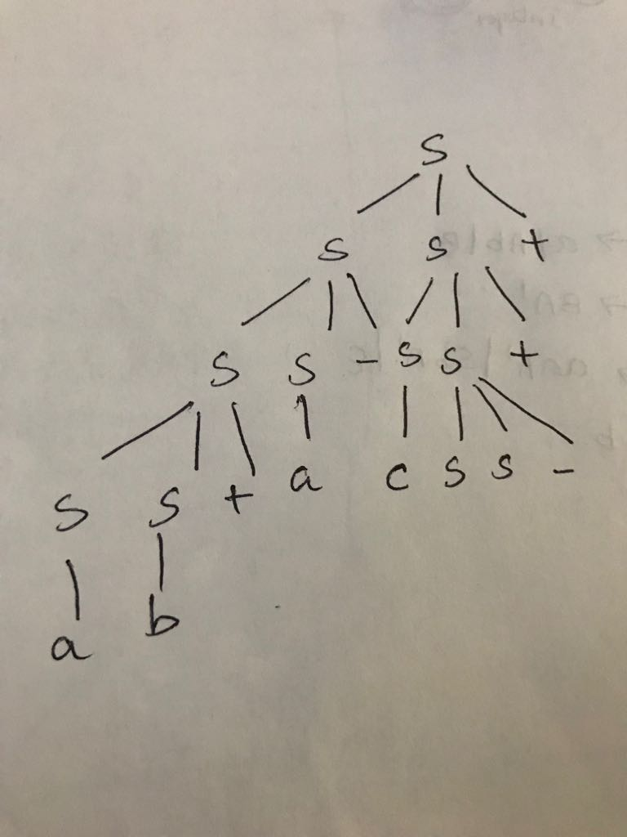

b. Phrases: ab+a-cSS-++

c. Simple phrases: ab+ / bb+ / aa+

d. Handle: SS+

S 🡪 SS+

S 🡪aS+

5.

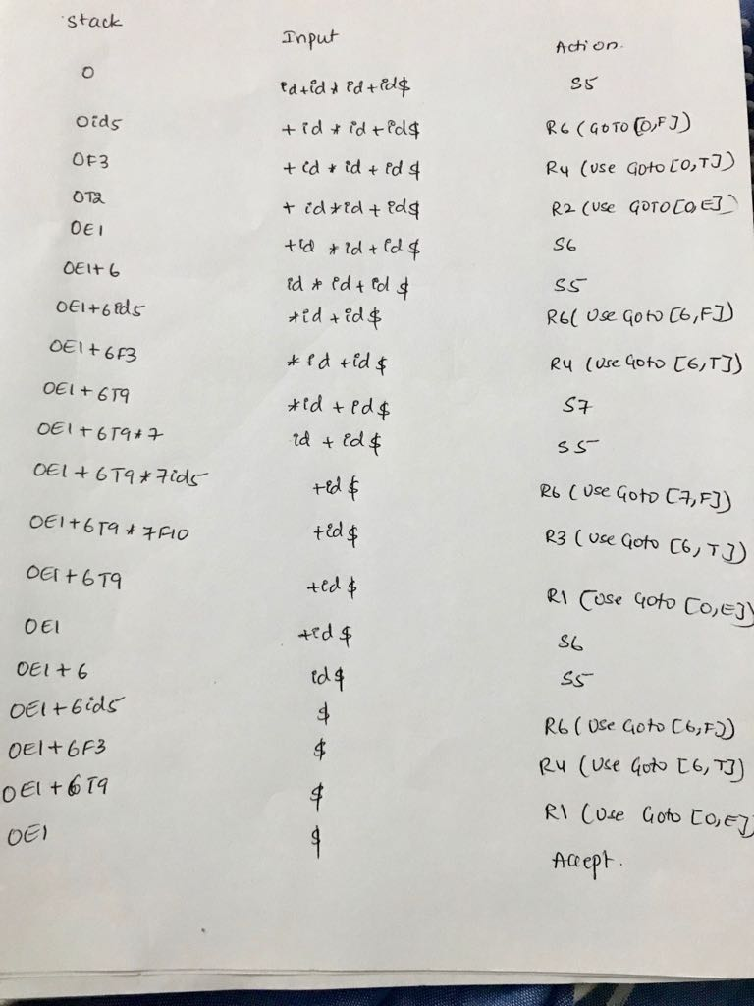

6.

a. Language implementation time

b. Language implementation time

c. Load time

d. Compile time.

e. Language design time.